**LAB 8**

Complete the provided RESTful Application [RestEmployee].

Add the validation annotation to the domain object.

Complete the Controller.

Complete the Ajax.

**Home page:**

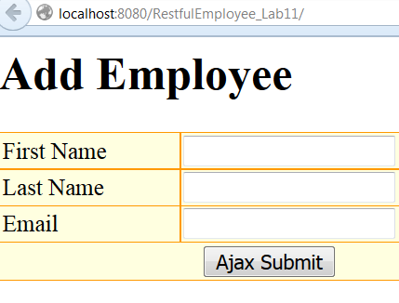

**Click Ajax Submit:**

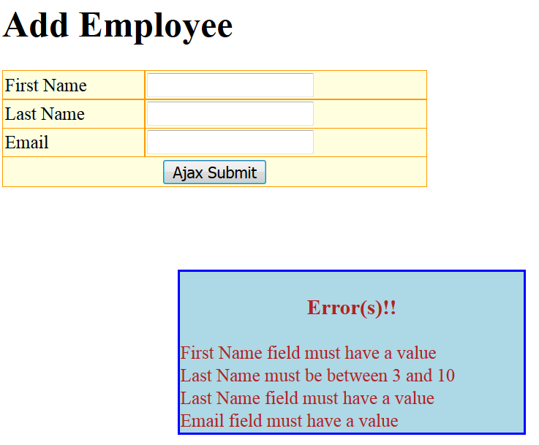

**Successful Submit**

